All About Pythons

The python challenge is an annual event that take place in Florida. Everglade the event has two purposes to raise awareness about the invasive Burmese python that is harming the ecosystem of the everglades.

Before an unpacked problem most of these snakes were first brought to Florida as exotic pet. People thought it would be exciting to have a python as a pet. Burmese python become popular as a pet in the early 1990 they were cheap. Just 20-30 a snake they are not venomous or likely to attack human. Terrestrial pythons are regularly found near water and are proficient swimmers, but they hunt and eat almost exclusively land.

After they released them into the wide these smart snakes made their way to the everglades. The Burmese python is one of the top five longest snakes in the word. They can grow up to 20 feet long and weigh up to 200 pounds. Burmese python can lay 50-100 egg per year. After the female lay her egg, she coils herself around them until they hatch about two or three months later. The females keep their incubating egg warm by contracts of twitching their muscles quickly. And they have no natural predictor in the everglades.

Finally, to solve the problem the fish and wildlife foundation of Florida started The Florida python challenge participants can sign up to hurt the Burmese python in the everglades. It’s a dangerous and difficult challenge but it has an impressive prize. Winners can win thousands of dollars with a grand prize of 10,000! It’s easy to participate all participate must register for the weeklong event and take an online training course. They also must learn how to humanely kill a python, which is a requirement to win a prize. Participants don’t need much else besides a little knowledge and a lot of courage!

Now you know all about the Florida python challenge.

By Za’Noyah Mouzan

I write too large for School

I’m sorry I write big.

I’m sooo sorry.

I think

I will

FAIL

By Kymier Dowdell

I have my brothers eyes

As dark as an olive

But I don’t like olives

I hold my dad’s slickness

I’m like the loch ness,

I hide as the snake

But relax like a sloth

By Dines Krivdic

I have my mom’s temper.

It’s as big as a pool.

I have my dad’s eyes. It’s as black as

A room with no light.

By Jared Godinez

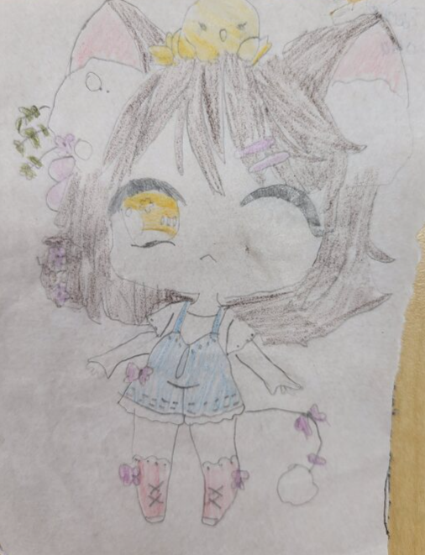

By Lyaneliz Delgado Rios